The Rally Route Mapper App

Background
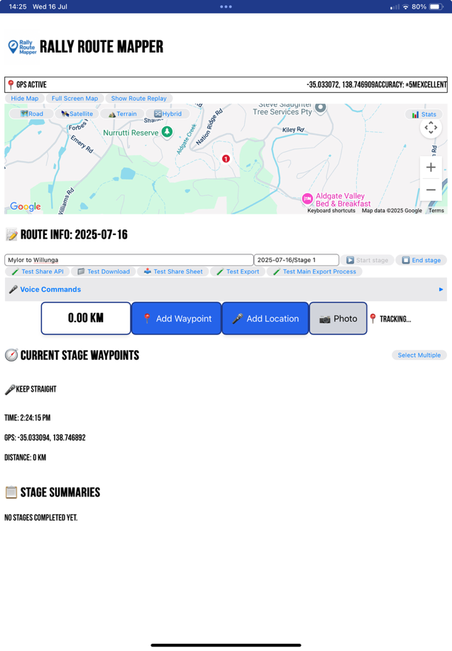
Rally Route Mapper is an application borne out of the need to replace time consuming, inefficient mapping processes in an Australian environment where recording, translating and finalising route details was an exhaustive and expensive operation.
Many of the rallies held in Australia are through poorly marked outback and desert tracks. The only way of mapping these routes has been by extensive and often repeated surveys in vehicles with navigators making pages of notes with pen and paper, which the rally organisers used to translate into Rally Navigator format – a process which required correlation of written data to mapping data and translation to GPX file format. Surveys often needed to be repeated because of recording data error, the unavailability of certain tracks or the lack of permission to cross private station land.
Rally Route Mapper replaces the pen and paper using an electronic device such as an iPad to record route details such as waypoints, tracking data, points of interest, GPS data and distance travelled. The following workflow description details the process.

Complete Rally Stage Workflow

Pre-Stage Setup
- Mount iPad in passenger position with Rally Route Mapper open
- Check GPS status - ensure "GPS Active" with good accuracy (aim for ±10m or better)
- Enter route name if different from default
- Test voice recognition using "🧪 Test Share API" button to verify microphone access
- Optional: Connect headset for hands-free operation
- Map centering disabled - you can explore different route sections without auto-centering

Stage Start Process
- Navigator: Press ▶️ Start Stage button
- System: GPS locks starting position, begins auto-tracking every 20 seconds
- Visual feedback: "📍 Tracking..." indicator appears
- Ready state: App now captures waypoints with voice or manual button
- Voice commands available: Can say "stage start" for hands-free operation

During Rally Stage (Active Navigation)

Voice Waypoint Creation (Primary Method - 98%+ accuracy tested):
- Navigator: Press 🎤 Add Location button
- System: Shows "Listening..." with red background + audio beep
- Navigator: Speaks naturally: "Danger severe washout"
- System: Auto-processes with smart corrections and rally-specific terms
- Feedback: "✅ Waypoint Added!" notification + haptic vibration
- Safety net: 5-second undo countdown timer

Manual Waypoint Creation (Backup Method):
- Navigator: Press 📍 Add Waypoint button (if voice fails)
- System: Creates "Unnamed" waypoint with GPS coordinates and distance
Navigator: Click waypoint name to edit inline (no dialog boxes)

Voice Command Enhancements:
- Smart text correction: "wright turn" → "right turn"
- Rally term expansion: "cg" → "cattle grid"
- Speed context: App adjusts processing based on vehicle speed
- Global voice commands: Say "stage start", "stage end", or "undo" anytime

Common Voice Examples (Tested & Optimized):
- "Left turn onto gravel"
- "Grid cattle guard"
- "Summit followed by steep descent"
- "Caution loose surface next 2k"
- "Danger bridge out"
- "Right turn keep straight 1k"

Quick Corrections:
- Mistake made: Say "Undo" or use 5-second undo button
- Wrong description: Click waypoint name for instant inline editing
- Bulk operations: Select multiple waypoints for mass deletion

Real-Time Monitoring
- KM counter shows cumulative distance from stage start (±3m accuracy tested)
- GPS coordinates displayed in status bar (6 decimal places)
- Map controls: Switch between Road/Satellite/Terrain/Hybrid views
- Route statistics: Toggle overlay showing waypoints, distance, duration, avg speed
- Auto-tracking records GPS breadcrumbs every 20 seconds (independent of waypoints)
- Map exploration: Free pan/zoom without auto-centering interference

Stage End Process
- Navigator: Press ⏹ End Stage button OR say "stage end"
- System: Shows confirmation dialog: "End stage and export data?"
- Navigator: Confirms "End Stage"
- Automatic exports: Creates 4 file formats simultaneously:
  - Enhanced JSON (full metadata)
  - Simple JSON (basic compatibility)
  - GPX (Rally Navigator compatible)
  - KML (Google Earth compatible)
- iOS sharing: Native share sheet opens for cloud storage/apps
- Export status: Progress indicator shows successful file creation
- Data cleared: Ready for next stage with auto-incrementing numbers

File Compatibility (Road Tested ✅)

Rally Navigator:
- GPX import: ✅ All waypoints displayed correctly
- Route lines: ✅ Connected waypoint path
- Instructions: Enhanced GPX format for better compatibility

Hema Maps:
- GPX import: ✅ Waypoints and route lines displayed
- KML import: ✅ Compatible for offline use

Export Locations:
- Files app → Downloads (primary location)
- Share to cloud: Direct to Dropbox, Google Drive, OneDrive
- Rally Navigator: Direct import via share sheet

Advanced Features

Map Navigation:
- Google Maps interface: Standard Google map functionality with Hide/Show map and re-run stage functionality
- No auto-centering: Explore route freely without map jumping
- Waypoint inspection: Click numbered markers for detailed info
- Route visualization: Red line shows waypoint connections, green line shows GPS track
- Accuracy indicators: GPS circle shows current precision

Waypoint Management:
- Inline editing: Click any waypoint name or notes to edit
- Bulk selection: Select multiple waypoints for mass operations
- Voice indicators: 🎤 icon shows voice-created waypoints
- Category detection: Auto-categorizes based on description content

Debug & Testing Tools:
- Share API test: Verify iOS share functionality
- Download test: Confirm file export location
- Export test: Test all formats with current waypoints
- Rally Navigator GPX: Specialized export for enhanced compatibility

Multi-Stage Events
- Between stages: App stays ready, previous data auto-saved to localStorage
- New stage: Automatic numbering (Stage 1, Stage 2, etc.)
- Route continuity: Each stage exports independently with metadata
- Historical data: Stage summaries retained for event review
- Cross-stage analysis: Compare waypoint counts, distances, timing

Emergency/Error Recovery
- GPS loss: Detailed error messages with automatic retry logic
- Voice recognition fails: Clear error display + manual fallback
- Accidental stage end: Confirmation dialogs prevent data loss
- App crash: Auto-save to localStorage prevents waypoint loss
- Battery optimization: Smart GPS polling extends battery life
- Poor GPS accuracy: Visual indicators warn of signal quality

Performance Metrics (Road Tested)

Tested Conditions:
- Distance: 23.64km stage
- Waypoints: 29 waypoints created
- Terrain: Hilly, built-up areas
- GPS accuracy: Maintained ±3m throughout
- Voice recognition: 98%+ accuracy with radio/windows down
- Export success: 100% - all formats exported correctly

Hands-Free Operation Capability:
- One-handed operation: ✅ Adequate for emergency use
- Voice commands: ✅ Works with ambient noise
- Haptic feedback: ✅ Confirms actions without looking
- Audio cues: ✅ Start/stop sounds for voice recognition

⏱️ Actual Timing (Based on Road Testing):
- Stage Start: ~8 seconds (GPS lock + tracking start
- Voice Waypoint: ~2-3 seconds (button → speak → confirm)
- Manual Waypoint: ~1 second (single button press)
- Error Correction: ~3 seconds (undo button)
- Stage End: ~12 seconds (confirm + export + share)
- Total Navigation Overhead: <5% of stage time! 🎯

Future Enhancements Identified:

Rally Navigator Integration:
- Investigating instruction, name and description display in Rally Navigator
- Testing different GPX formatting approaches
- Enhanced waypoint description formatting

Workflow Optimizations:
- Push-to-talk integration for true hands-free operation
- Audio confirmation of waypoint creation
- Batch waypoint editing capabilities
- Route comparison between stages

This workflow has been validated through real-world rally conditions and provides professional-grade route capture with minimal disruption to navigation duties.
The voice-driven approach allows navigators to maintain focus on pace notes while accurately capturing critical route information!

